✅ 1. Competitor Analysis (Indian Market)
Primary Competitors
These are active players in the beauty, skincare and lifestyle ecommerce space in India:
1. Nykaa
- Leading beauty & wellness ecommerce platform in India.
- Offers both international and domestic cosmetic & skincare brands.
- Strong brand trust, customer reviews, loyalty program.
2. Myntra
- Major fashion & beauty retailing website (part of Flipkart ecosystem).
- Wide range of lifestyle, personal care, and beauty products.
- Large customer base & frequent discount events.
3. Voonik
- Online marketplace focused on women’s fashion and beauty items.
- Offers curated selections from multiple brands.
2. Unique Selling Propositions (USPs)
1. 100% Organic & Vegan Products
Products are pure plant-based skincare—appealing to health- and eco-conscious buyers.
2. Cruelty-Free & Eco-Friendly Packaging
No animal testing and responsibly sourced packaging—important differentiator vs mass brands.
3. Natural Botanical Formulas for Sensitive Skin
Products designed for gentle use can attract customers who are tired of chemical-heavy mainstream products.
4. Personalized Brand Experience
Direct communication with buyers, custom recommendations, and tailored support.
5. Ethical & Sustainable Brand Story
Consumers increasingly choose brands with purpose and planet-friendly missions.
3. Campaign Objective
Selected Campaign Objective:
Sales (Conversions) / Website Conversions
Why This Objective?
Primary goal is to increase actual purchases on your ecommerce website — not just traffic or awareness.
A Sales / Conversions campaign on Google Ads focuses on showing your products to users who are most likely to buy based on their search intent.
Justification:
- Search ads reach customers when they are actively searching for skincare/beauty products.
- The objective will be optimized toward clicks that convert into purchases.
- With a budget of ₹1000/day for 15 days, you can attract targeted search traffic and improve sales while collecting data for future campaigns.
Campaign Type:
• Google Search Campaign – to show product ads when people search keywords like “organic skincare products”, “natural face serum”, “vegan skincare India”, etc.
Budget: ₹1000 per day for 15 days
Bid Strategy:
• Target CPA (cost per acquisition) or Maximize Conversions
Targeting:
• India
• Interests: beauty & skincare shoppers
Ad Extensions:
• Sitelinks for featured products
• Callout extensions (FREE shipping / 100% Vegan / Cruelty-Free)
4.Google Ads Setup Screenshots
a) Objective selection screen.
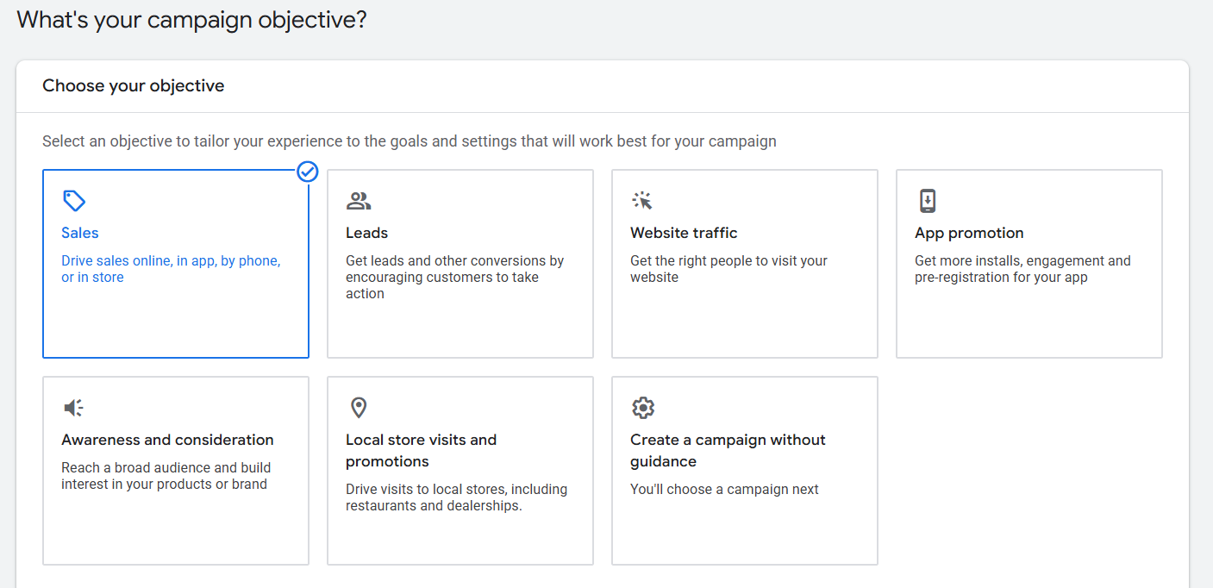
b) Budget, dates and ad schedule (if you applied)
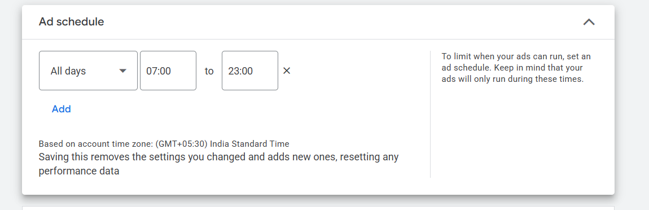
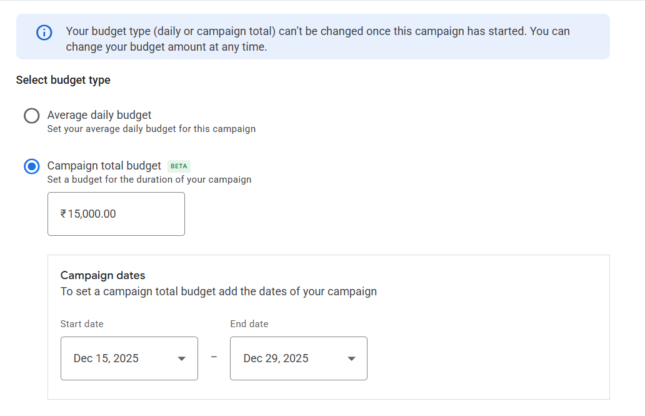
c) List of keywords research for the campaign, with their search volume and competition. (If your applied)
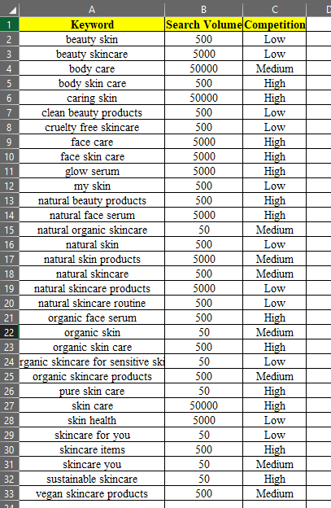
d) Target audience setup, include (Location, Demographic, Audience segments), and other targeting (device, networks, etc.)
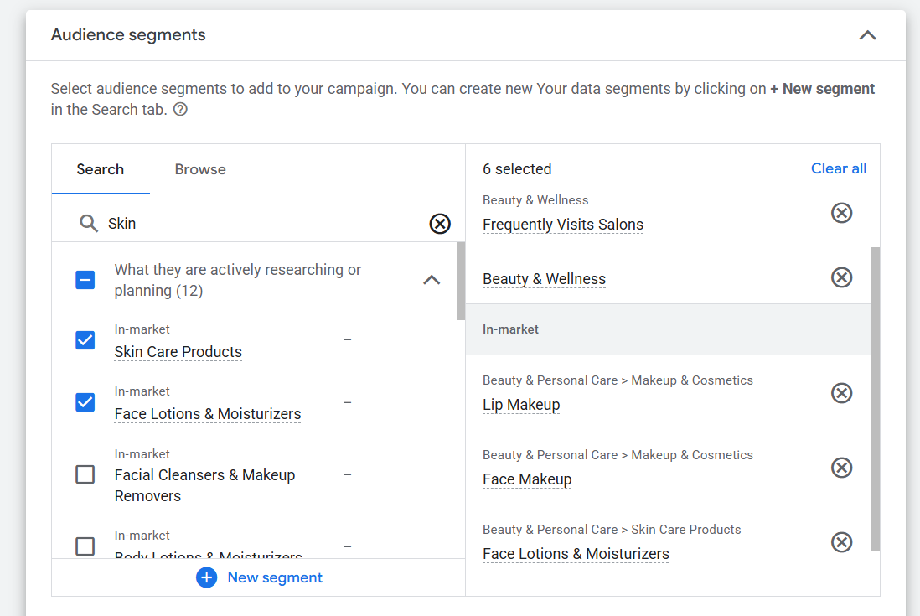
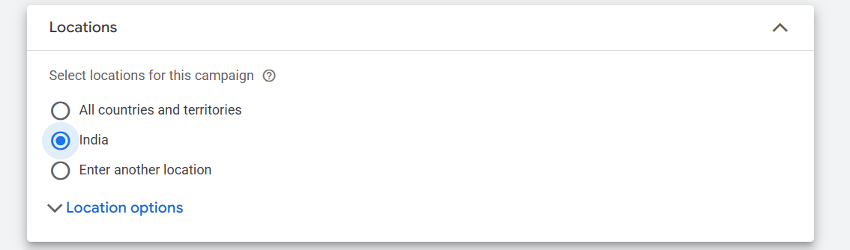
e) Screenshot of your Ad creative.
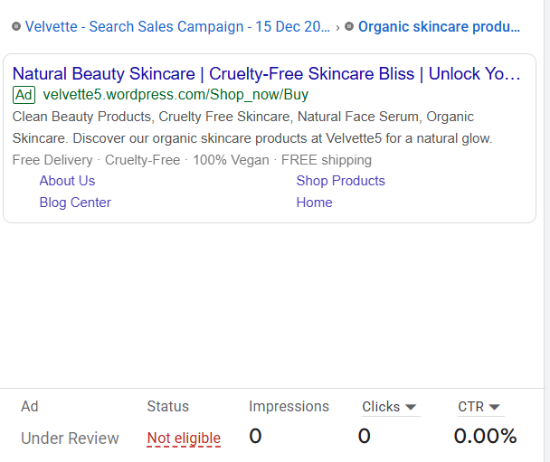
f) Estimated campaign results
